Student Name : _________HOU JUNNING___________________

Group : __________SCS1__________________

Date : __________2025/10/15__________________

LAB 4: ANALZING NETWORK DATA LOG

You are provided with the data file, in .csv format, in the working directory. Write the program to extract the following informations.

Exercise 4A: TOp TALKERS and LISTENERS

One of the most commonly used function in analyzing data log is finding out the IP address of the hosts that send out large amount of packet and hosts that receive large number of packets, usually know as TOP TALKERS and LISTENERS. Based on the IP address we can obtained the organization who owns the IP address.

List the TOP 5 TALKERS

Rank | IP address | # of Packets | Organization
1 | 13.107.4.50 | 5960 | MICROSOFT-CORP-MSN-AS-BLOCK, US
2 | 130.14.250.7 | 4034 | NLM-GW, US
3 | 155.69.160.38 | 3866 | NTU-AS-AP Nanyang Technological University, SG
4 | 171.67.77.19 | 2656 | STANFORD, US
5 | 155.69.199.255 | 2587 | NTU-AS-AP Nanyang Technological University, SG

TOP 5 LISTENERS

Rank | IP address | # of Packets | Organization
1 | 137.132.228.33 | 5908 | NUS-AS-AP NUS Information Technology, SG
2 | 192.122.131.36 | 4662 | A-STAR-AS-AP A-STAR, SG
3 | 202.51.247.133 | 4288 | NUS-GP-AS-AP NUS Gigapop, SG
4 | 137.132.228.29 | 4022 | NUS-AS-AP NUS Information Technology, SG
5 | 103.37.198.100 | 3741 | A-STAR-AS-AP A-STAR, SG

Exercise 4B: TRANSPORT PROTOCOL

Using the IP protocol type attribute, determine the percentage of TCP and UDP protocol

 | Header value | Transport layer protocol | # of packets
1 | 6 | TCP | 137707
2 | 17 | UDP | 36851
3 | 0 | HOPOPT | 1216
4 | 50 | ESP | 718

Exercise 4C: ApplicationS PROTOCOL

Using the Destination IP port number determine the most frequently used application protocol.
(For finding the service given the port number https://www.adminsub.net/tcp-udp-port-finder/ )

Rank | Destination IP Port Number | # of Packets | Service
1 | 443 | 43208 | HTTPS
2 | 80 | 11018 | HTTP
3 | 50930 | 2450 | Unknown(Dynamic)
4 | 15000 | 2103 | hydap
5 | 8160 | 1354 | BMC Patrol

Exercise 4D: Traffic

The traffic intensity is an important parameter that a network engineer needs to monitor closely to determine if there is congestion. You would use the IP packet size to calculate the estimated total traffic over the monitored period of 15 seconds. (Assume the sampling rate is 1 in 2048)

Total Traffic( MB) | 331901.12 MB

Exercise 4E: ADDITIONAL ANALYSIS

Please append ONE page to provide additional analysis of the data and the insight it provides.
Examples include:
Top 5 communication pairs;
Visualization of communications between different IP hosts;
etc.

Please limit your results within one page (and any additional results that fall beyond one page limit will not be assessed).

Exercise 4F: SOFTWARE CODE

Please also submit your code to the NTULearn lab site.

1.Top 5 Communication Pair
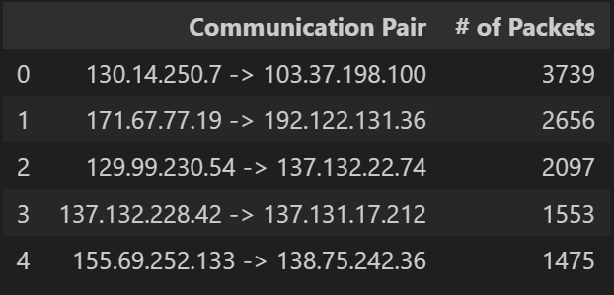

2.Visualizing the communication between different IP hosts
- Bar graphs for top 20 communication pairs, shown in ‘# of packets’ and ‘MB’ respectively.
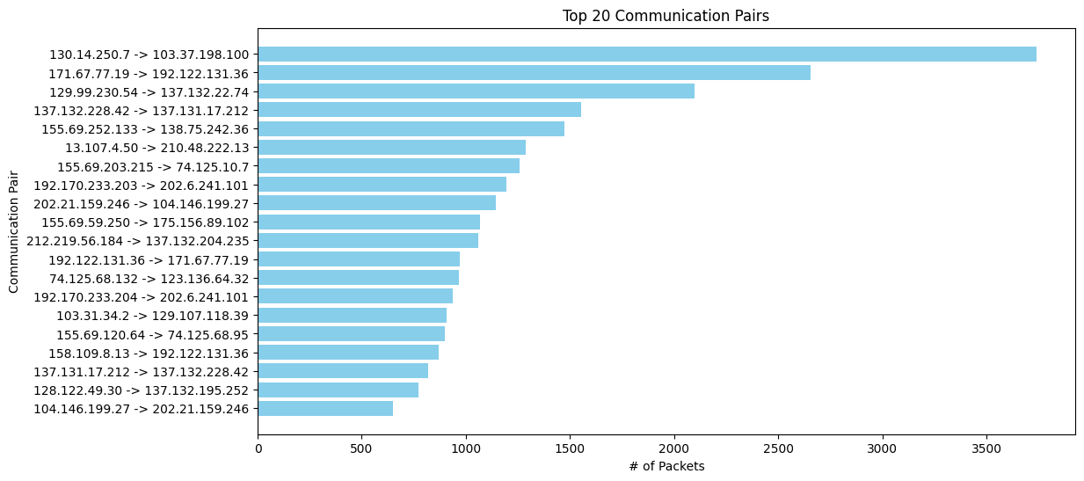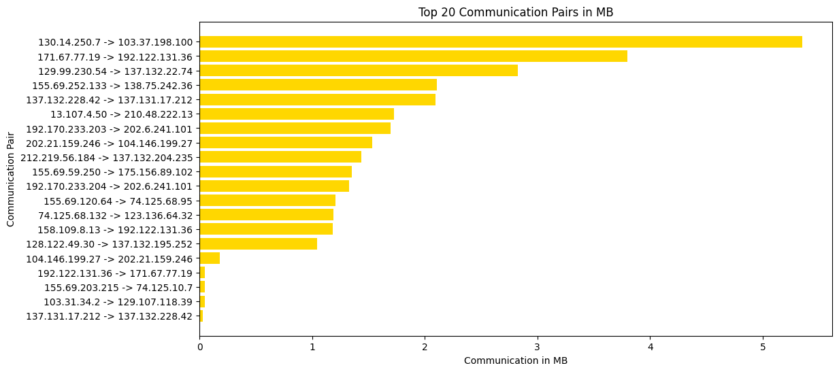
The bar chart provides a clear ranking of the most active communication pairs in the network.
Each bar represents a pair of source and destination IPs. This makes it easy to identify which pairs dominate the traffic, showing a few pairs contributing a significant portion of total communication volume.

- Network Graph for top 20 communication pairs, shown in ‘# of packets’ and ‘MB’.
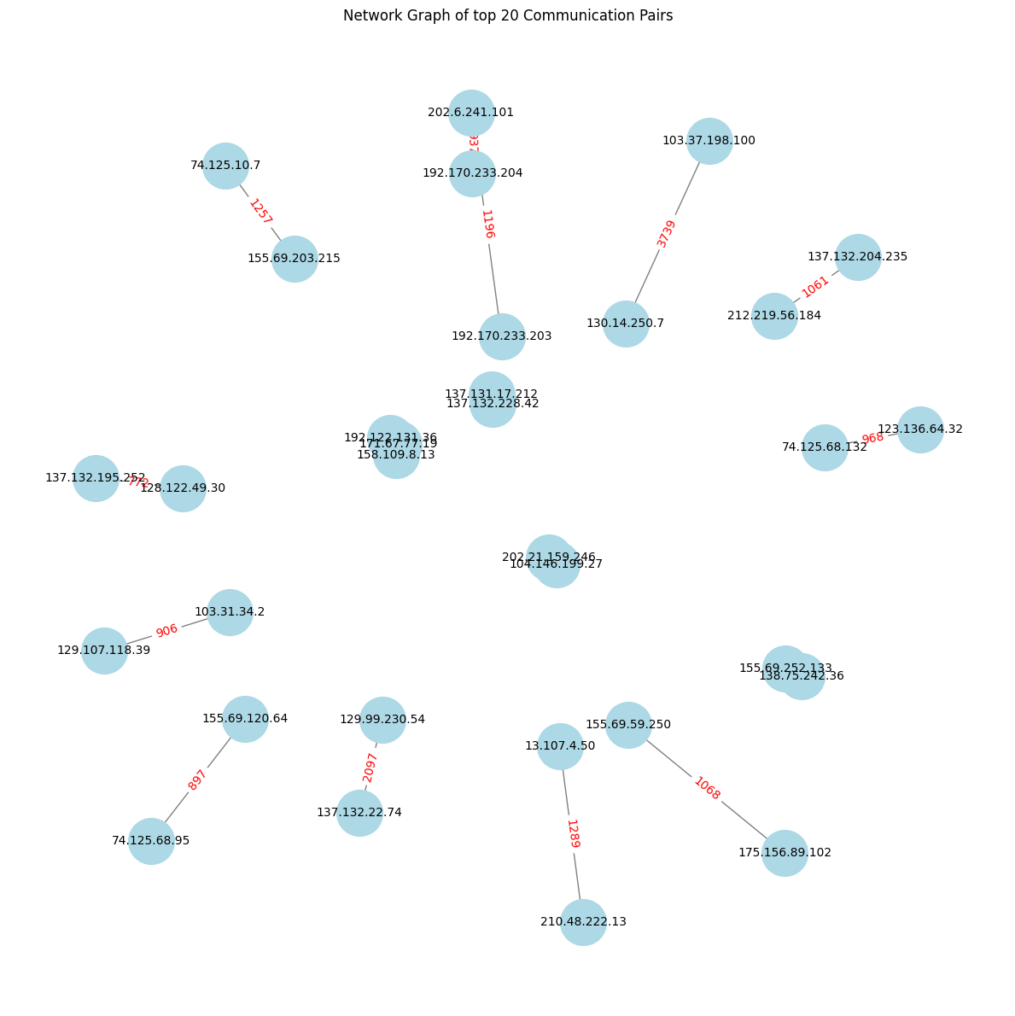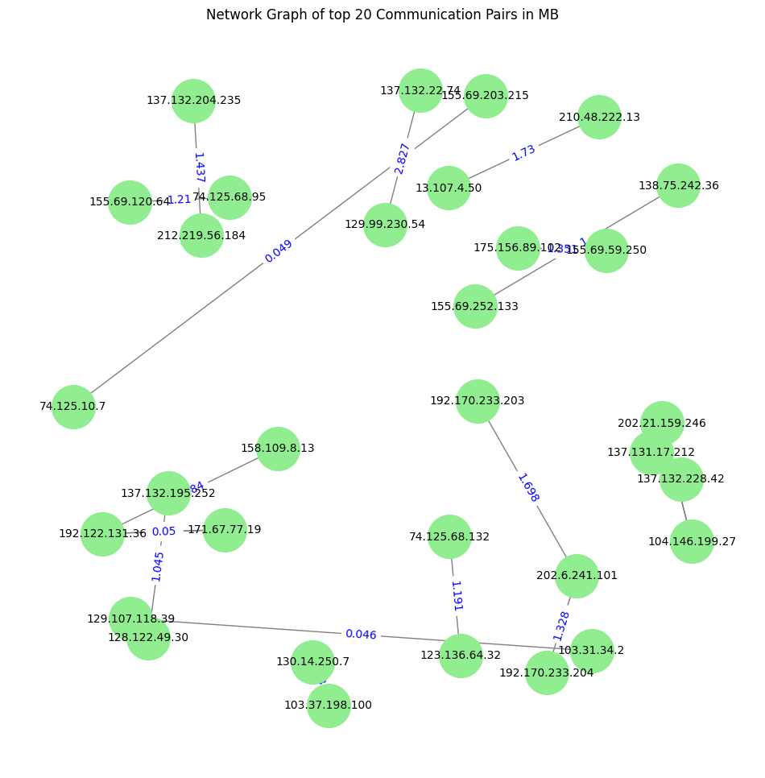
The network graph visualizes the connections between the top 20 pairs as nodes and edges.
Nodes represent IP addresses, while edge labels reflects the traffic volume between them.
The graph indicates that a small number of highly active nodes is acting as major traffic hubs.

- Chord Diagram and heatmap of top 20 communication pairs, shown in ‘# of packets’ and ‘MB’.
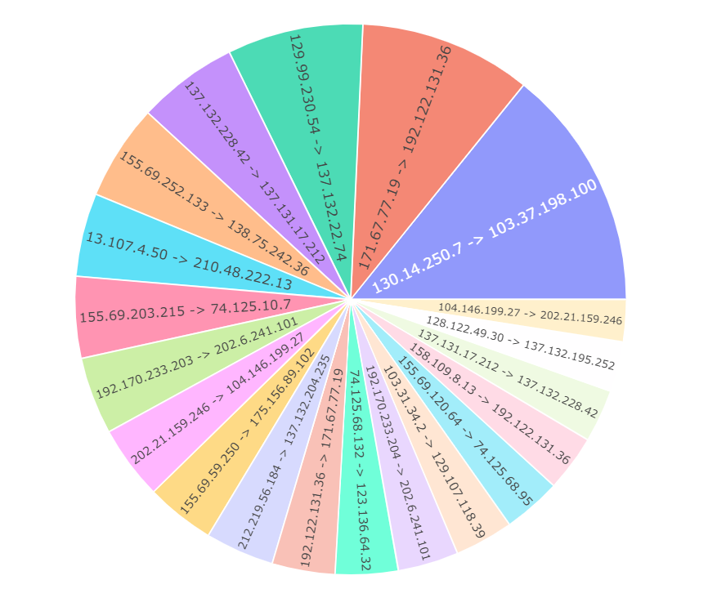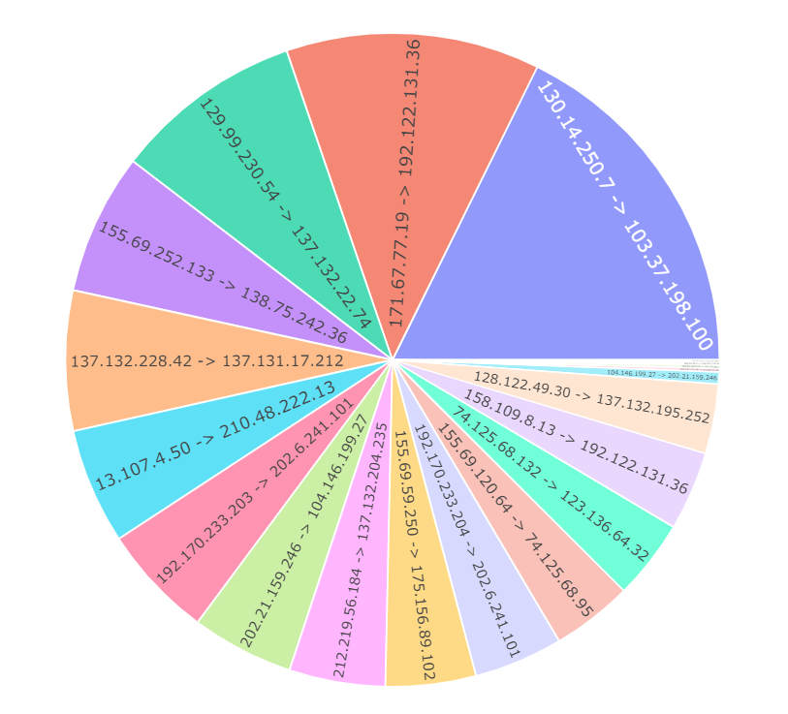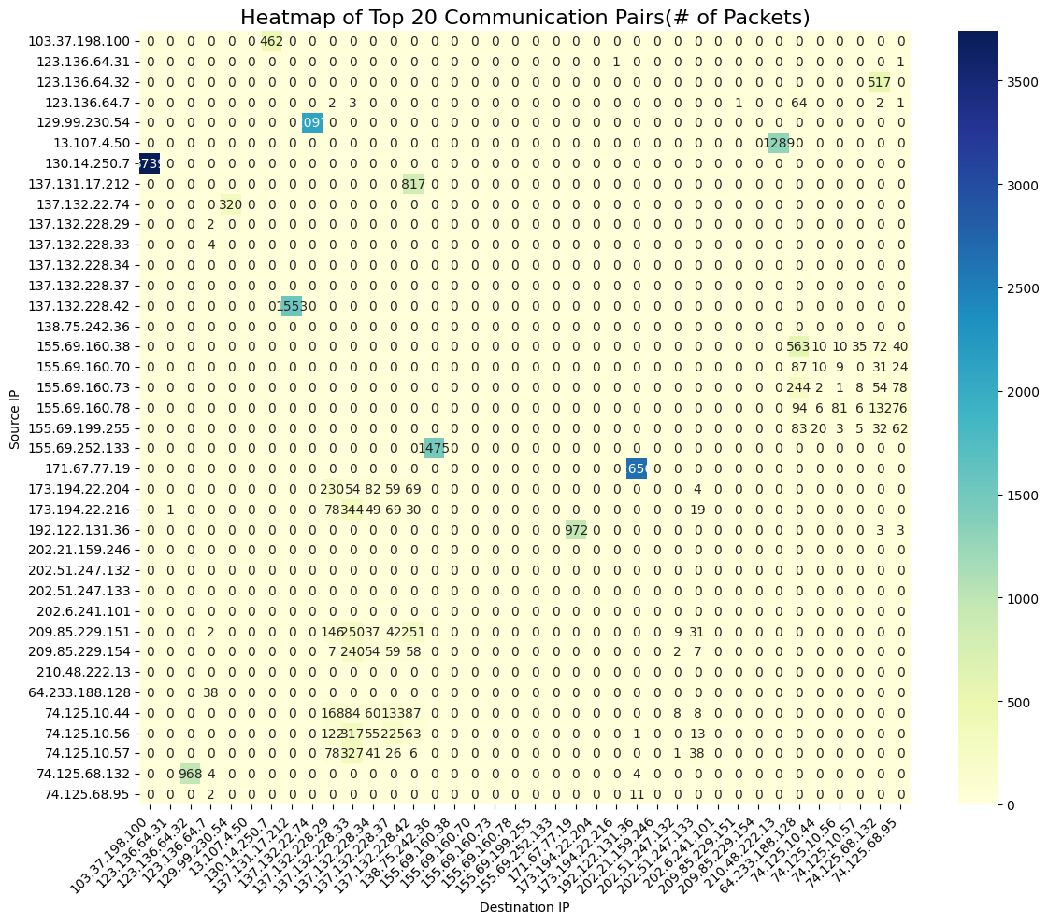
The chord diagram highlights the bidirectional relationships among the top communication pairs. The width of each chord corresponds to the traffic intensity between two IPs.
The heatmap provides a matrix-style overview of communication intensity among the top 20 IPs.
This visualization allows quick identification of traffic hotspots and clearly shows that most communication is concentrated in a few IP pairs, while the majority of combinations have little or no traffic.
- Summary analysis
Across all four visualizations, the same pattern emerges: network traffic is highly concentrated among a few communication pairs. A handful of IP addresses act as dominant talkers and listeners, while most nodes remain relatively inactive.This core–edge structure suggests the presence of key service endpoints or external data sources.

